

360 SMS APP



User Guide for 360SMS Open API



360 DEGREE CLOUD TECHNOLOGIES PVT. LTD.

# **Table Of Contents**

1. Introduction to the Open API Functionality.

1. Sending Messages.

1. Receiving Delivery Callback.

1. Receiving the Reply.

1. Limitations.

# **Introduction to the Open API Functionality:**

The 360SMS is predominantly an SMS application based completely out of the Salesforce platform. The user needs to have a well configured Salesforce org in order to access the 360SMS managed package.

In order to make the functional services provided by 360SMS available outside the Salesforce platform, we are providing a set of one API and two Webhooks for allowing the user to interact with their customers. The API is used for sending the messages while the Webhooks are used for receiving the delivery callbacks for the sent SMS from the user’s systems and receiving the incoming SMS.

# 

# **Sending Messages:**

The user will be able to communicate with their end clients from their platforms using the services provided by 360SMS through Open API configuration. The document for the API configuration can be accessed here.

In order to send a message from your own platform or User Interface, you will have to follow the following steps:

1. Configure the API endpoints as per directed in the API documentation with your system.

1. Here’s a node.js interface that is being used to send messages to the end users.

1. From this interface, when the user types a message in the box., enters the registered number of the end user and clicks on the “Send Message” button, the end user will receive the message on their phone.

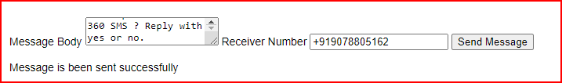

*Fig 1: Send SMS from your own platform.*

# 

# 

# **Receiving the Delivery Callback.**

Whenever the user sends out a message, a webhook will be triggered which will capture the status of the message and this message will be received by the user. This message will be displayed at the bottom of the screen.

1. Type the message in the text box (ref Fig 1)

1. Click on the send message button.

1. The message containing the status and Id of the record will be visible below.

# 

# **Receiving the Reply**.

Whenever the client replies to the message sent by the user with a certain text or number, the reply coming from the client will also be displayed on the screen.

1. Type a message in the text box.

1. Send the message.

1. Whenever the customer replies to the message, it will be visible at the bottom portion of the screen.

# **Limitations:**

Currently, the functionality is configured for only the Whatsapp Channel. With one API, the user can send up to 200 SMS. In case the user wants to send more than 200 SMS, they will have to purchase APIs in multiples of 200.